How to check the progress of a ticket or add a comment or attachment?

Once you have logged into the portal you will notice your name will be displayed on the top right-hand corner of your screen. Please click on your name and select requests to monitor the progress of your incident or requests.

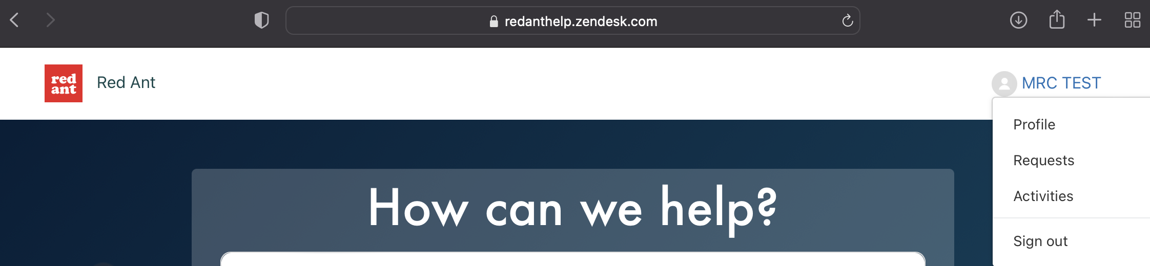

Using the My requests section you can now monitor the progress of your tickets, for further details of a ticket or to chase/escalate a request please click on the summary text under Subject.

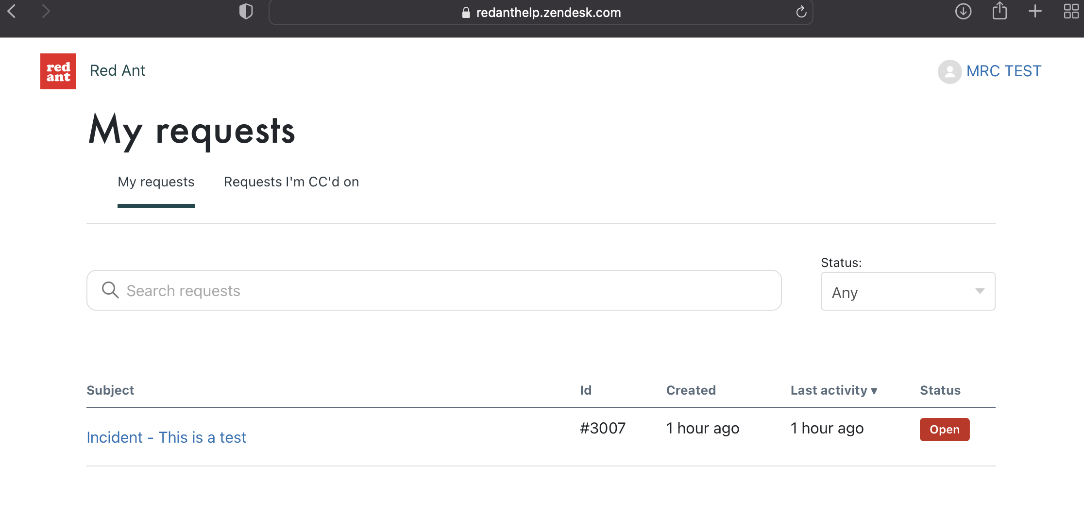

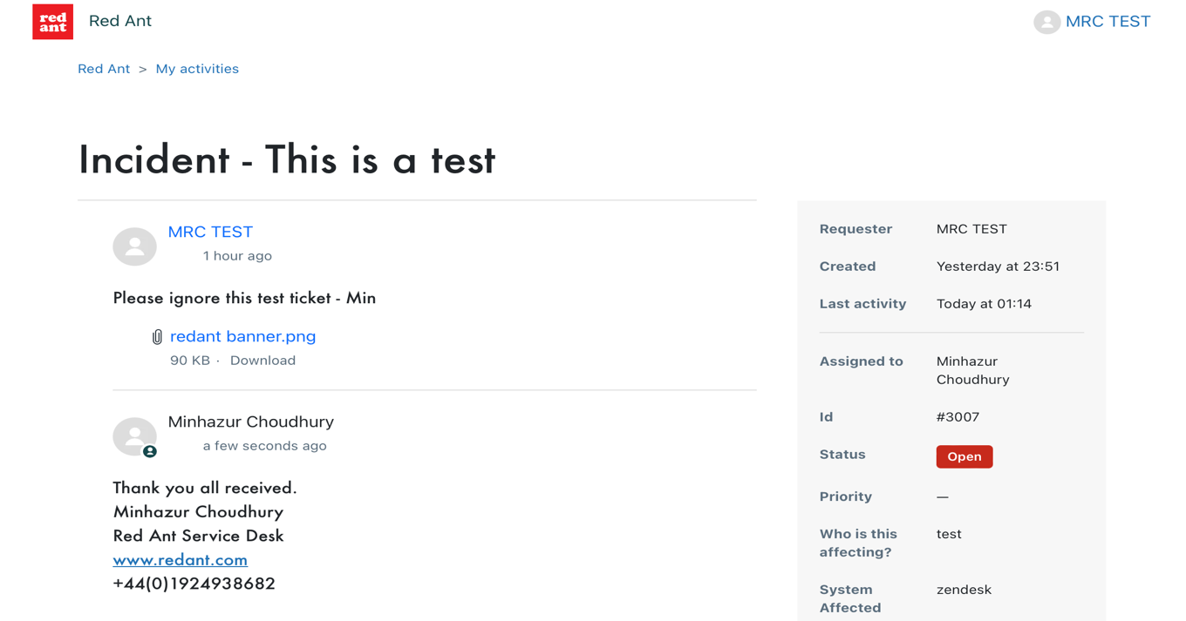

To add a comment, chase, or request for an update you can use the free text window then select submit once done. Please note if the service desk requests for further information or Images, you can use the Add file or drop files here section to attach a file to the ticket.

