How do I Login to the Portal?

Please use the Sign in option situated on the top right-hand corner of your screen to easily check the progress of your ticket at any time or to chase, escalate a ticket.
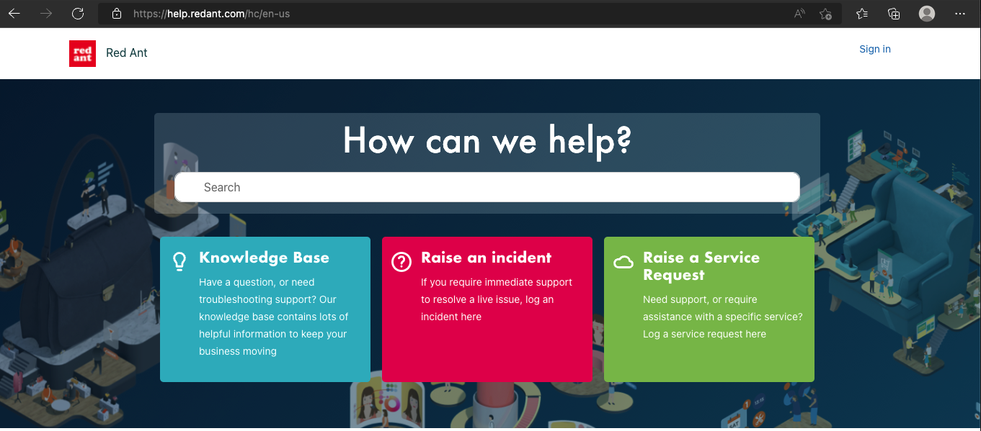

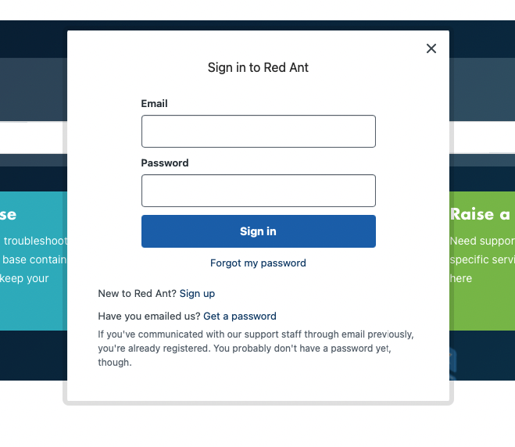
Please register by clicking on Sign up or if you have communicated with our support staff through email previously, you’re already registered, and you can click on the Get a password option and follow the on-screen instructions.
Please enter your email address as per the onscreen instructions
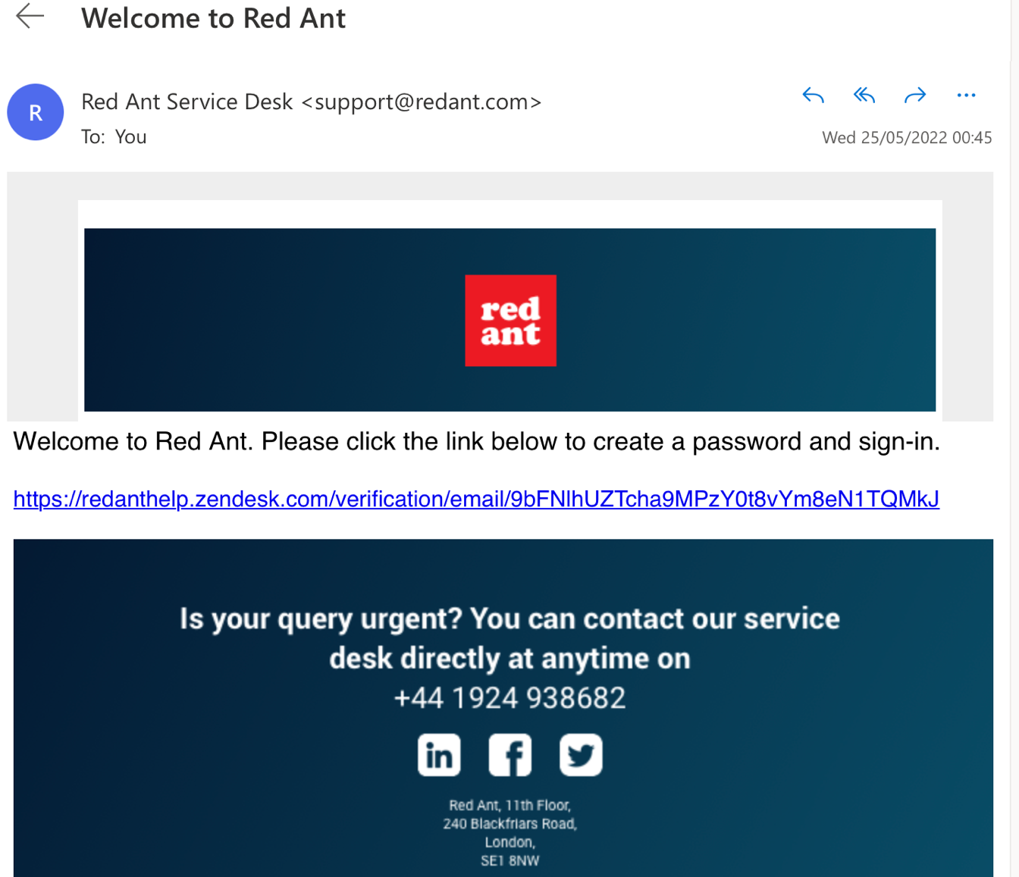
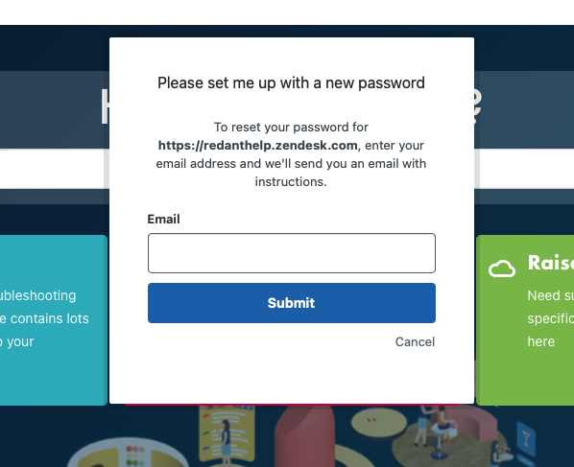
Check your inbox for the email from Red Ant Zendesk and follow the onscreen instructions

Enter your name and choose a password then select Set password

