How do I access the Zendesk Portal?

Please use the link below to access the Zendesk Support Portal.

<https://redanthelp.zendesk.com/>hc/en-us

Please note the Zendesk Portal is browser agnostic and is compatible with most web browsers however we would recommend using one of the following:



Google Chrome Edge Chromium

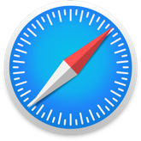

Firefox Safari

